Software Requirements Specification

For Minor Project

*POORNIMA PAYMENTS*



|  |  |
| --- | --- |
| Prepared by:  Aditya Laxkar  PCE/15/IT/003  Tushar Gupta  PCE/15/IT/061 | Guide:  Mr. Shirish Nagar  Asst. Prof.-IT |
| Department of Information Technology,  Poornima College of Engineering  13/8/2018 Session – 2018-19 | |
|  | |

Table of Contents

|  |  |
| --- | --- |
| Table of Contents | Page No. |
| 1. Introduction | III |
| 1.1 Purpose | III.I |
| 1.2 Feasibility | III.I |
| 2. Functional /Nonfunctional Requirements | IV-IX |
| 2.1 Functional Requirement | IV-V |
| 2.2 Nonfunctional Requirements | V-VII |
| 2.3 Technical Requirments ( Hardware /Software) | VIII-IX |
| 3. System Features | IX-XIII |
| 3.1 Module 1 | IX |
| 3.2 Module 2 | X |
| 3.3 Module 3 | X |
| 3.4 Module 4 | X-XIII |
| 4. Analysis Diagrams | XIV-XXI |
| 4.1 Use Case Diagram  4.2 Sequence Diagram  4.3 Component diagram  4.4 Data Flow Diagram(Optional)  4.5 ER Diagram  4.6 Activity Diagram  4.7 Project Schedule Diagram |  |
| 5. Other Requirements | XXII |
| 6. Glossary | XXII |
| 7. Appendices | XXIII |
| 8. References | XXIII |
| 9. Guide’s Comments | XXIII |

# Introduction

## Purpose

Purpose of creating this application is to take one step further towards digital marketing as by doing digital transaction we can reduce the baggage of carrying paper currency instead of using digital way of payment.

Also it will be helpful for users to keep track of their monthly expenses. This application will also provide some benefits like coupons, offers, %off on purchase, extra benefits.

* 1. **Feasibility**
  + Reliability: The solution should operate with minimum fault in normal condition as well as withstand unexpected circumstances. This criterion is very important due to its link to finance and the distrust of the customers for the new payment method.
  + Security: The solution relates to the protection of payment details and customers’ identity besides preventing business fraud to happen. In short, it should cover the issues of anonymity, privacy and non-repudiation
  + Speed of payment process: The speed of payment process has to be very fast as the customer could not wait patiently for a micro payment transaction and get frustrated with delay.
  + Social acceptability: The new payment process could highly be affected by the market acceptance which mostly comes from public’s prior knowledge and previous experiences with existing mobile payment method.
  + In INDIA, mobile payment based on premium SMS has been widely implemented and used in the private companies. It inevitably gives premium SMS method the edge over other competing methods in public opinions.

## Functional /Nonfunctional Requirements

## Functional Requirements

### **2.1.1 User Registration**

* User needs to login to application
* Valid ID should be updated in order to use application
* Email must be used in order to login

### **2.1.2 Add Money to Wallet**

### ***User must be able to add money to wallet using debit or credit card***

* *Card must be authenticated from bank by admin before allowing user to transact payments.*

### **2.1.3 Transfer money**

* User must be able to transfer money to another user.
* User must be able to make payments using this application

### **2.1.4 Add cards to user profile**

* User must be able to add their debit/credit cards to application with bank authentication
* If any user tries to fraud application by invalid cards then application must be able to detect these frauds.

### **2.1.4 Maintain customer profile.**

1. *The system shall allow user to create profile and set his credential.*
2. *The system shall authenticate user credentials to view the profile.*
3. *The system shall allow user to update the profile information.*

### **2.1.5 Provide personalized profile**

1. *The system shall display both the active and completed payment history in the customer profile.*
2. *The system shall allow user to select the last payment from the payment history (passbook).*

### **2.1.6 Provide user Support.**

1. *The system shall provide online help, FAQ’s customer support, and sitemap options for customer support.*
2. *The system shall allow user to enter the customer information for the support.*
3. *The system shall display the online help upon request.*
4. *The system shall display the FAQ’s upon request.*

### **2.1.7 Email confirmation.**

1. *The system shall maintain user email information as a required part of user profile.*
2. *The system shall send a payment confirmation to the user through email.*

### **2.1.8 Detailed invoice for user.**

1. *The system shall display detailed invoice for current payment once it is confirmed.*

### **2.1.9 Offer online promotions and rewards.**

1. *The system shall display all the available promotions to the user.*
2. *The system shall allow user to select available promotion.*

## ****2.2 Nonfunctional Requirements****

## ****2.2.1 Usability****

**2.2.1.1 Performance Requirements**

*•You will be sign in within 26 sec.*

*•If anybody make new account then they will receive confirmation email* *within 6 minutes.*

*•Credit card validate within 5 sec.*

*•Web support 250 customers logged at the same time*

**2.2.1.2 Safety Requirements**

•*We will try the best to make product safe.*

**2.2.1.3 Security Requirements**

*•Web app will validate credit cards against fraud.*

*•Web app keep the information of the customers and merchants safe.*

*•Web app obeys all the security laws of INDIA relating to cyber traffic.*

*•The commission decided between merchant and administrator will not be published.*

**2.2.2 Software Quality Attributes**

*•The web app well is easy to use.*

*• Web app will be easy to learn how to operate it.*

*•The web app will show easy to locate buttons*

*•The web app use simple English so that user cannot confuse with terms.*

*•The web app should be easy to upgrade*

**2.2.2.1 Graphical User Interface**

* *The system shall provide a uniform look and feel between all the application pages.*
* *The system shall provide a digital image for each product in the product catalog.*
* *The system shall provide use of icons and toolbars.*

### **2.2.2.2 Accessibility**

* *The system shall provide handicap access.*
* *The system shall provide multi language support.*

## ****2.2.3 Performance****

* *The product shall be based on web and has to be run from a web server.*
* *The product shall take initial load time depending on internet connection strength which also depends on the media from which the product is run.*
* *The performance shall depend upon hardware components of the client/customer.*

## ****2.2.3 Security****

### **2.2.3.1 Data Transfer**

* *The system shall use secure sockets in all transactions that include any confidential customer information.*
* *The system shall automatically log out all customers after a period of inactivity.*
* *The system shall confirm all transactions with the customer’s mobile application.*
* *The system shall not leave any cookies on the customer’s device containing the user’s password.*
* *The system shall not leave any cookies on the customer’s device containing any of the user’s confidential information.*

### **2.2.3.2 Data Storage**

* *The customer’s mobile application shall never display a customer’s password. It shall always be echoed with special characters representing typed characters.*
* *The customer’s mobile application shall never display a customer’s credit card number after retrieving from the database. It shall always be shown with just the last 4 digits of the credit card number.*
* *The system’s back-end servers shall never display a customer’s password. The customer’s password may be reset but never shown.*
* *The system’s back-end servers shall only be accessible to authenticated administrators.*
* *The system’s back-end databases shall be encrypted.*

## 2.3 Technical Requirments ( Hardware /Software)

## **2.3.1 **Interfaces****

* *There are many types of interfaces as such supported by the Poornima Payment software system namely; User Interface, Software Interface and Hardware Interface.*
* *The protocol used shall be HTTP.*
* *The Port number used will be 80.*
* *There shall be logical address of the system in IPv4 format.*

### **2.3.1.1 User Interfaces**

* The user interface for the software shall be compatible to any browser such as Internet Explorer, Mozilla or chrome by which user can access to the application.
* *The user interface shall be implemented using any tool or software package like Android Studio.*

### **2.3.1.2 Hardware Interfaces**

* Since the Poornima Payment application must run over the internet, all the hardware shall require to connect internet will be hardware interface for the system. As for e.g. internet connectivity with device is must.

### **2.3.1.3 Software Interfaces**

* The Poornima Payment system shall communicate with the Configurator to identify all the available components to configure the product.
* The Poornima Payment shall communicate with the content manager to get the product specifications, offerings and promotions.
* The Poornima Payment system shall communicate with bill generation system to identify available payment methods, validate the payments and process payment.
* The Poornima Payment system shall communicate to credit management system for handling financing options.
* The system shall be VeriSign like software which shall allow the users to complete secured transaction. This usually shall be the third party software system which is widely used for internet transaction.

### **2.3.1.4 Communications Interfaces**

* The Poornima Payment system shall use the HTTP protocol for communication over the internet and for the intranet communication will be through TCP/IP protocol suite.

# System Features

## Module 1: USER

## Payer (customer)

* Payer register on application if new user?
* If payer is an existing user then will login using user id and password.
* Make payment request to Payee via application.
* Payment can be made either using mobile no. or QR-CODE.
* Payer will add money in wallet if balance is low or payment amount exceeds wallet balance.
* Payer can add money to wallet using any valid credit card or debit card.
* If money added to wallet successfully then payer can make payment otherwise payment will be declined.
* Payer can check all transaction history made by payer in Account passbook.

Other features for Payer

* Can edit personal profile (customization of profile allowed).
* Can transfer money to other user.
* Ask for change password if user forgets current password.

## Payee (service provider)

* Payer register on application if new user?
* If payer is an existing user then will login using user id and password.
* Make payment request to Payer via application.
* Payment can be made either using mobile no. or QR-CODE.
* Money will be added to wallet once transaction from payer side completed.
* Payee can check all transaction history made by payer in Account passbook.

Other features for Payer

* Can edit personal profile (customization of profile allowed).
* Can transfer money to other user.
* Ask for change password if user forgets current password.

## Module 2: Bank management

* Will check all validation to credit card or debit card information given by users.
* Authentication to admin about user’s transaction will be done by bank.
* Can ask admin to deactivate user account or block card if found faulty.

## Module 3: Admin Panel

* Admin can check all details of all users.
* Admin can deactivate any user account if found breaching code of conduct.
* Admin will take care of all managing all details of all users and payments.
* Admin can also add money to any users account if required.
* Admin also require to add money to wallet using credit card or debit card. For making any payments.
* Admin can reset users account password if requested by user.
* Admin can keep track on user’s activity in application.
* Admin will have access to database of the application
* Admin can check all transactions history done via Poornima Payment application
* Admin can add coupons, offers and discount deals to the application.
* Admin can update all canteen items their prices, departmental store items and their prices.

**Module 4: System Working**

**3.4.1 USER REGISTRATION & WELCOME**

* ***Only appears once (the first time the application is run)***
* ***Allows the user to register with the Split Pay server***
* ***Enables the user to customize his/her account settings and preferences***

**3.4.2 GROUP CREATION & MANAGEMENT**

* ***Streamlines the process of creating and organizing groups***
* ***Provides support for multiple groups***
* ***Allows the user to add group members manually or from contacts list***

**3.4.3. POSTING A BILL**

* ***Stores and monitors the bill amount, the individuals involved, etc.***
* ***Includes support for multiple simultaneous bills***
* ***Efficiently distributes debt amongst the individuals responsible for the bill***

**3.4.4. MEMBER-TO-MEMBER TRANSACTIONS**

* ***Enables group members to simulate transfers of debt, payments made, etc.***
* ***Adjusts member balances accordingly***
* ***Records relevant information (amount paid, members involved, etc.)***

**3.4.5. FINAL DEBT RESOLUTION**

* ***Calculates the most efficient method of sorting out debts***
* ***Notifies group members of unresolved debts, credits, etc.***
* ***Offers the option to disband a group once all payments are made***

**3.4.6. GROUP HISTORY**

* ***Automatically records all transactions and bills posted to each group***
* ***Provides users with access to a detailed history of transactions***
* ***Supports sorting transactions by date, amount, payer, etc.***

**3.4.7. SHOW ALL DEBTS**

* ***Enumerates all of a user’s unresolved debts across each group he/she is a part of***
* ***Provides easy access to relevant information (past transactions, group info, etc.)***
* ***Offers the option to resolve a debt (or debts) immediately***

**3.4.8. SETTINGS MENU**

* ***Allows the user to customize his/her preferences***
* ***Enables the user to modify certain features and functionalities***
* ***Can be accessed at any time using the built-in Settings button on Android phones/IOS Phones.***

**3.4.9. HELP MENU**

* ***Displays a list of topics covering the different components of SplitPay***
* ***Offers detailed information on each feature, menu, etc.***
* ***Can be accessed at any time via the Settings menu***

**3.4.10. PUSH NOTIFICATIONS**

* ***Appear after any significant event occurs in a group***
* ***Alert group members of newly incurred expenses***
* ***Remind users of unresolved debts***

**3.4.11. RECEIPT IMAGING**

* ***Utilizes the camera built into Android handsets***
* ***Records and stores a snapshot of receipts associated with different expenses***
* ***Provides a method of checking/verifying expenses posted to a group***

**3.4.12. E-MAIL/SMS NOTIFICATIONS**

* ***Extends the standard notifications service built into Split Pay***
* ***Automatically delivers notifications via e-mail and/or text message***
* ***Enables individuals without Split Pay to receive group notifications***

**3.4.13. SPLITPAY TUTORIAL**

* ***Provides an abridged version of the Help menu for first-time users***
* ***Offers a step-by-step run through of each feature, menu, etc.***
* ***Enables any user to quickly and easily take advantage of all of Split Pay’s***

***Functionalities***

* ***A major functionality present in several of these features is automatic synchronization. Using***
* ***Android’s internet capabilities, the application periodically communicates with the Split Pay***
* ***Server. This allows bills, transactions, groups, and group histories to be uploaded to a central***
* ***Server where the data can be shared with all other Android users in the group. This process of***
* ***Exchanging data between the server and the phone(s) is referred to as syncing.***

**1. MEMBER DEBT VISUALIZATION**

* ***Presents a visual representation of current member balances***
* ***Allows users to navigate through financial information in a more intuitive fashion***
* ***Automatically updates as users post expenses and make transactions***

**2. PAYPAL INTEGRATION**

* ***Incorporates a mechanism for initiating real transactions***
* ***Facilitates secure, hassle-free transactions between members***
* ***Automatically updates member balances as transactions occur***

**3.4.14. GPS TRACKING**

* ***Stores location data associated with certain events***
* ***Utilizes Google Maps to display transaction locations***
* ***Creates an expense map which can be viewed by all members of a group***

# Analysis Diagrams

* 1. **Use Case Diagram**

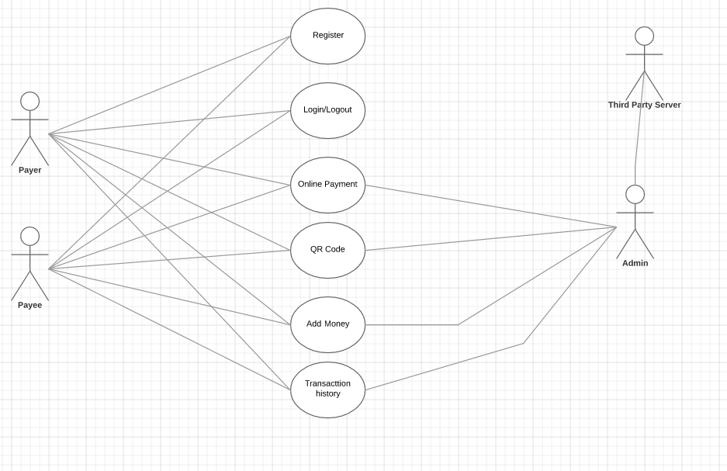

* 1. **Sequence Diagram**

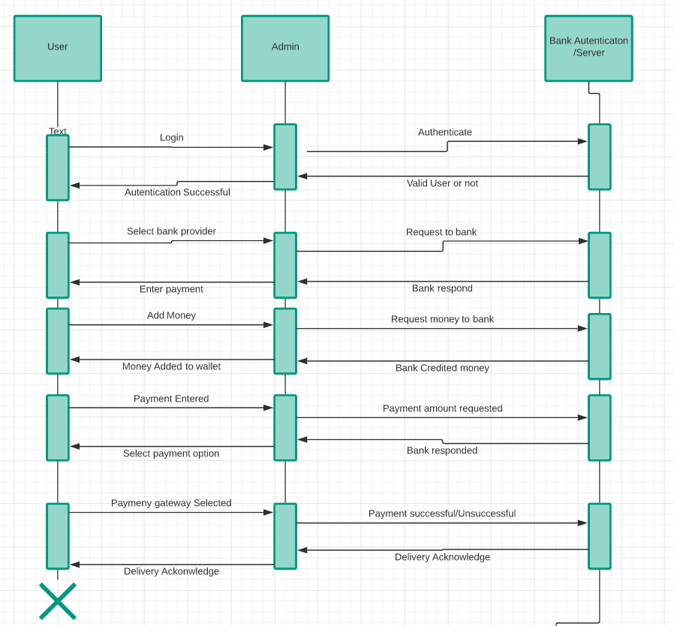

**3.3 Component diagram**

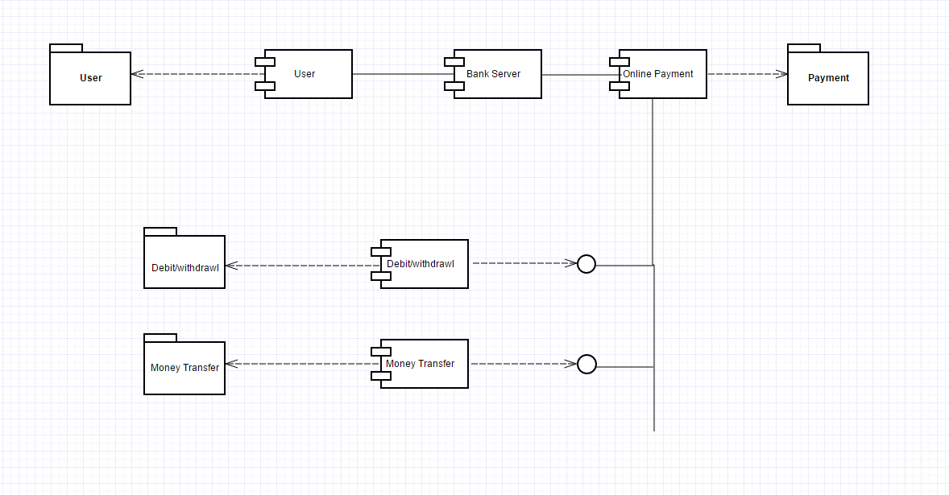

**3.4 Data Flow Diagram**

**Level-1**

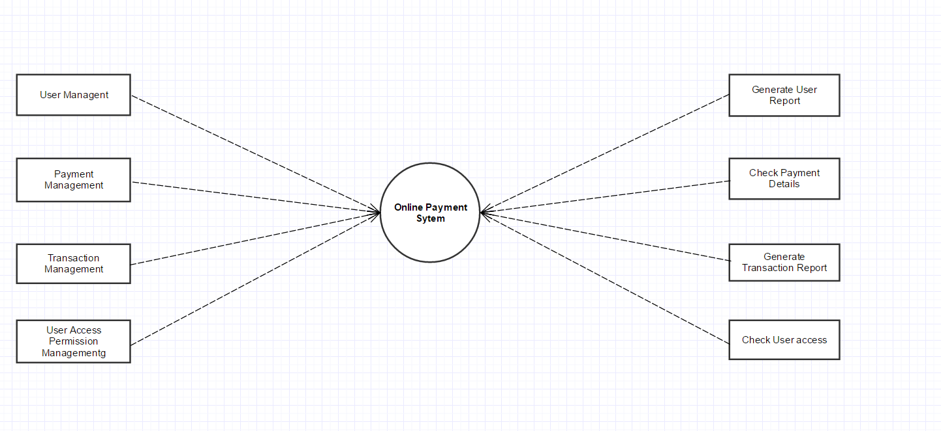

**Level-2**

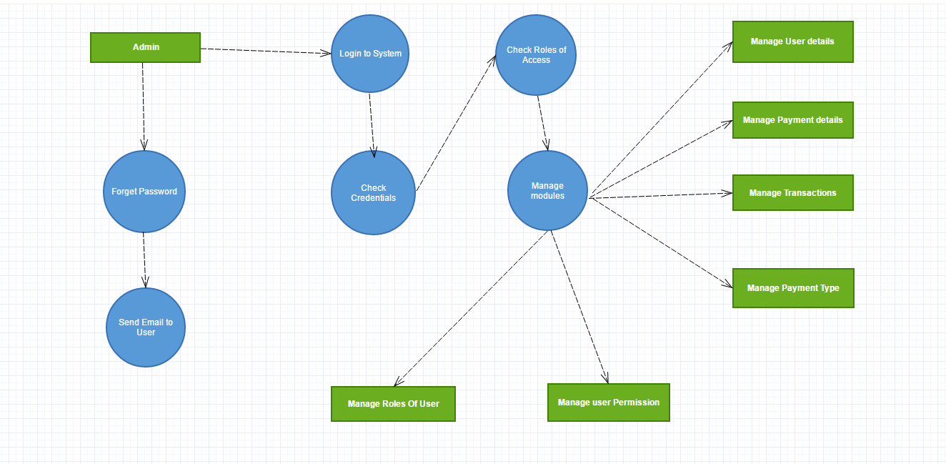

**3.5 ER Diagram**

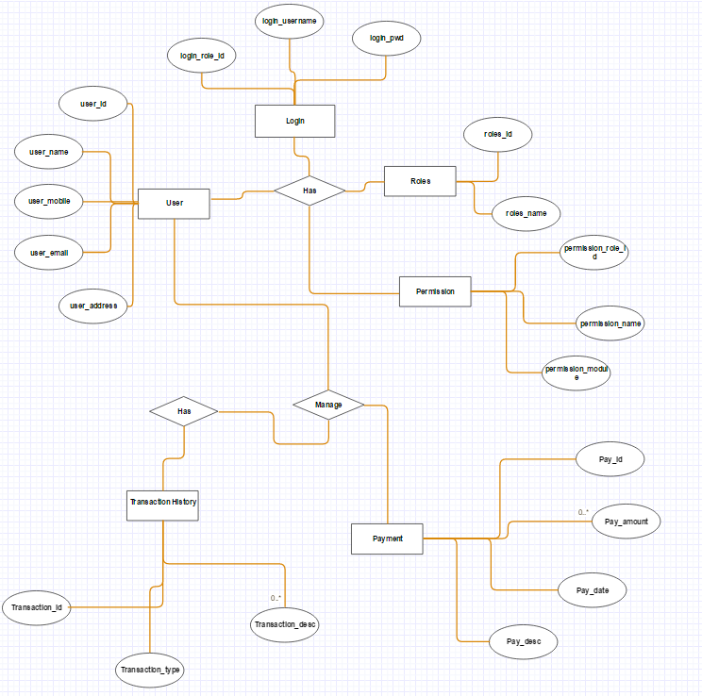

**3.6 Activity Diagram**

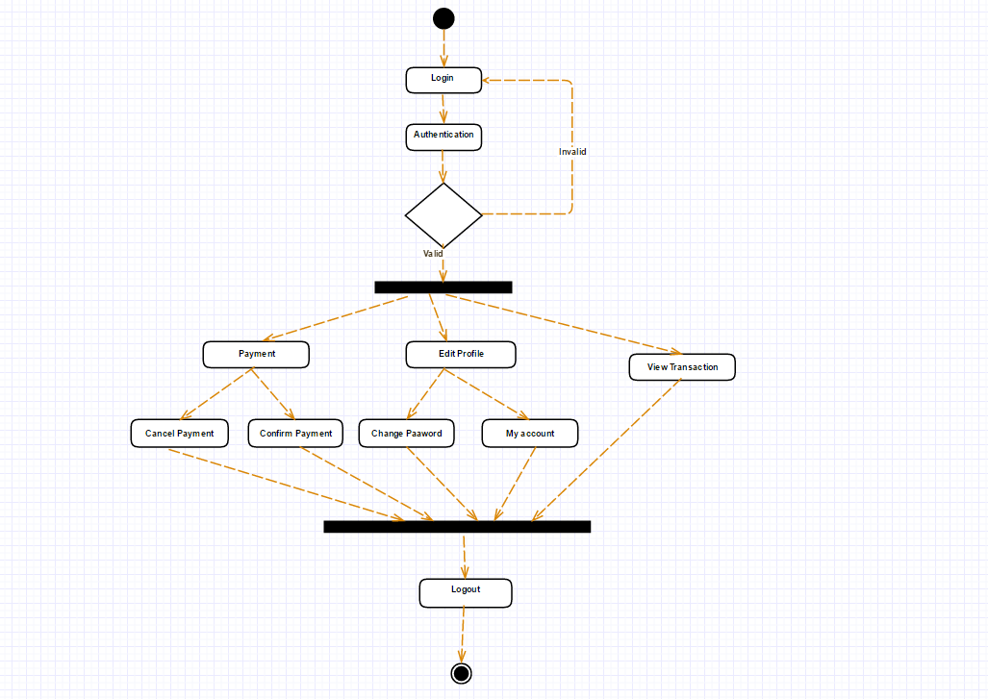

**3.7 Project Schedule Diagram**

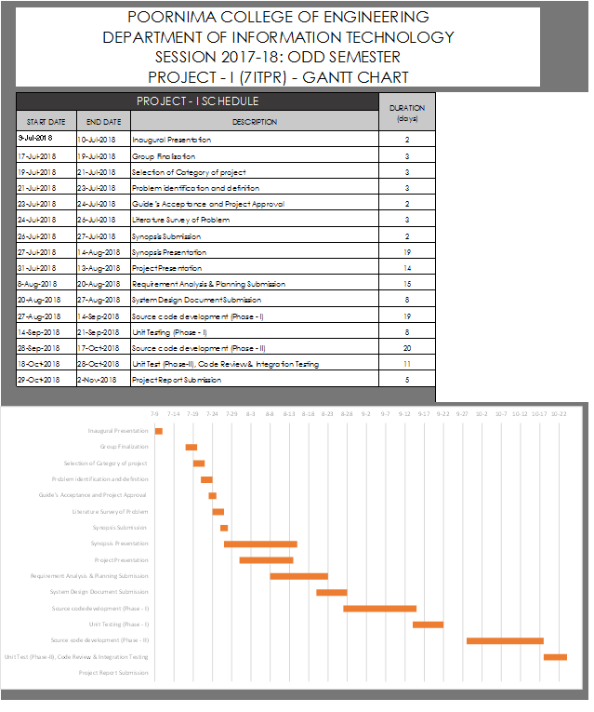

# Other Requirements

## ****5**.**1 Supportability****

### **5.1.1 Configuration Management Tool**

* *The source code developed for this system shall be maintained in configuration management tool.*

## ****5.1.2 On-line User Documentation and Help System Requirements****

**A**s the product is Poornima Payment, On-line help system becomes a critical component of the system which shall provide –

* It shall provide specific guidelines to a user for using the Poornima Payment system and within the system.
* To implement online user help, link and search fields shall be provided.

## ****5.2** **Licensing Requirements****

* Not Applicable

## ****5.3** **Legal, Copyright, and Other Notices****

* Poornima Payment should display the disclaimers, copyright, word mark, trademark and product warranties of the Marvel electronics and home entertainment.

## ****5.4** **Applicable Standards****

* It shall be as per the industry standard.

# Glossary

# Appendices

# References

* ***References: http://developer.android.com/reference/android/hardware/Camera.html***
* ***http://developer.android.com/guide/topics/location/index.html***
* ***Reference: http://code.google.com/apis/maps/documentation/places/***
* ***Reference:*** [***https://www.x.com/community/ppx/dev-tools***](https://www.x.com/community/ppx/dev-tools)
* [***https://sachinsdate.wordpress.com/2013/04/27/non-functional-requirements-in-mobile-applications/***](https://sachinsdate.wordpress.com/2013/04/27/non-functional-requirements-in-mobile-applications/)
* ***www.stackoverflow.org***

# Guide’s Comments